Inside the Earth
Outer Core
How hot is it?
What’s it made of?
How deep is it?

Inner Core
How hot is it?
What’s it made of?
How deep is it?

As we go through the slides, use the information to colour the layers of the Earth and fill in the boxes.

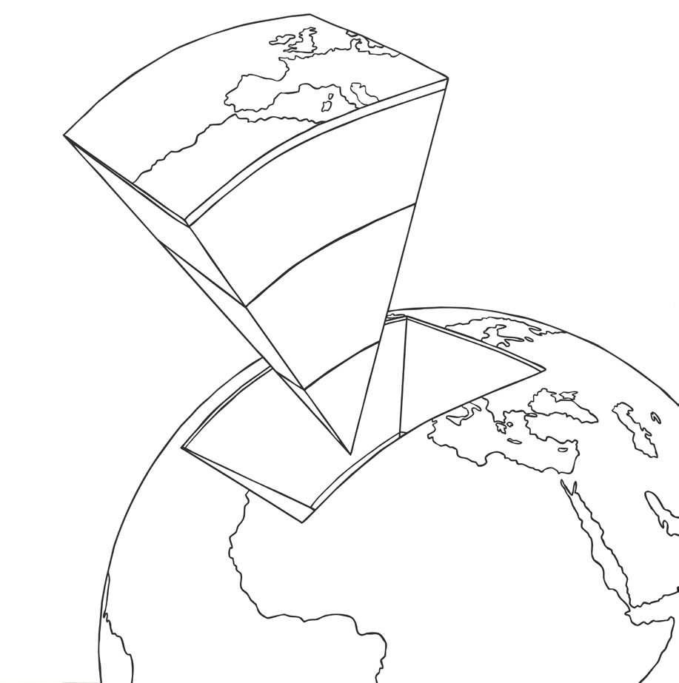

Crust
How hot is it?
What’s it made of?
How deep is it?

Mantle
How hot is it?
What’s it made of?
How deep is it?

